Traffic Shaping vs Traffic Policing
In the world of network traffic management, Traffic Policing and Traffic Shaping are two essential Quality of Service (QoS) mechanisms used to control the flow of data across a network. While both techniques are designed to manage bandwidth and regulate network traffic, they serve different purposes and are implemented in distinct ways. Understanding the differences between traffic policing and shaping is crucial for optimizing network performance and ensuring smooth operation of critical applications.
This article will explore the core concepts of traffic policing and traffic shaping, their differences, and when to use each in real-world networking scenarios.
What Is Traffic Policing?
Traffic Policing is a QoS mechanism used to enforce bandwidth limits on a network. It works by monitoring the rate at which data packets are transmitted over an interface and taking immediate action if the data exceeds a specified threshold. When traffic exceeds the allowed bandwidth, policing can either drop excess packets or mark them for lower priority transmission, depending on the configuration.
Traffic policing is often used to ensure that traffic stays within a certain rate, ensuring that higher-priority traffic can be delivered without being overrun by lower-priority or misbehaving traffic flows.
How Traffic Policing Works:
- Measurement: Policing measures the rate of traffic passing through an interface. If traffic exceeds the configured rate, it is classified as "non-conforming."
- Action on Excess Traffic: Excess traffic can either be dropped outright (packet loss) or marked with a lower priority using Differentiated Services Code Point (DSCP) values. Marked packets are still forwarded but treated with less priority in subsequent network processing.
- Token Bucket Algorithm: Policing often uses a token bucket algorithm to monitor the rate of traffic. If traffic consumes more tokens (representing bandwidth) than allowed, it's penalized based on the policing policy.
Key Characteristics of Traffic Policing:
- Strict Enforcement: Policing imposes strict limits, dropping or marking excess traffic once the bandwidth threshold is exceeded.
- Immediate Action: When traffic exceeds the limit, the router or switch takes action immediately, dropping or marking packets.
- Packet Dropping: Since policing can result in packet loss, it’s typically used in networks where occasional loss of low-priority data is acceptable.
What Is Traffic Shaping?
Traffic Shaping, on the other hand, is a QoS technique designed to smooth out traffic flows by delaying excess traffic rather than dropping it. Shaping works by buffering excess packets and releasing them at a controlled rate, allowing the traffic to conform to a desired bandwidth profile. This ensures that traffic is transmitted in a more predictable and controlled manner, which is particularly useful when dealing with bursty traffic patterns.
Traffic shaping is commonly used in scenarios where maintaining the flow of data is more important than dropping packets, such as in networks handling sensitive traffic like voice, video, or critical data transfers.
How Traffic Shaping Works:
- Buffering: When traffic exceeds the configured rate, excess packets are temporarily stored in a buffer (queue) instead of being dropped. The excess packets are released when bandwidth becomes available, ensuring smoother data flow.
- Rate Limiting: Like policing, shaping also enforces bandwidth limits. However, instead of discarding traffic that exceeds the limit, shaping sends it more slowly by pacing it over time.
- Token Bucket Algorithm: Shaping also uses a token bucket mechanism, but instead of dropping packets when the token limit is reached, it queues the traffic for transmission at a slower rate.
Key Characteristics of Traffic Shaping:
- Traffic Smoothing: Shaping smooths out traffic bursts by buffering excess packets, avoiding sudden spikes in traffic.
- No Packet Loss: Unlike policing, shaping does not drop packets but delays their transmission, making it ideal for traffic that cannot tolerate loss.
- Latency Increase: Since shaping buffers excess traffic, it can introduce some latency. This makes it less suitable for real-time applications like voice or video, where low latency is critical.
Key Differences Between Traffic Policing and Traffic Shaping
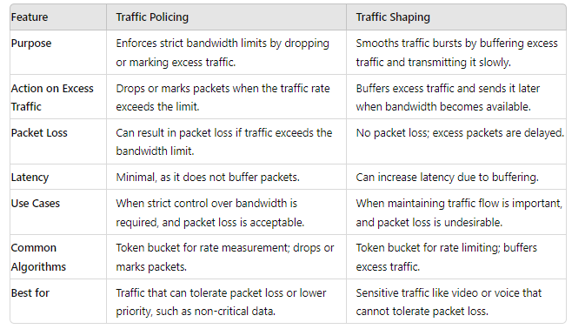
When to Use Traffic Policing
Traffic policing is typically used in scenarios where it's critical to enforce bandwidth limits, even at the cost of packet loss. This is useful in environments where:

- Bandwidth control is a priority: For example, in service provider networks where customers are assigned specific bandwidth limits, policing ensures that no customer exceeds their allocated bandwidth.
- Low-priority traffic can be dropped: In networks with non-critical traffic, such as web browsing or file downloads, packet loss may be acceptable.
- Rate enforcement at the edge of the network: Policing is often deployed at the edge of networks to limit incoming or outgoing traffic rates.
When to Use Traffic Shaping
Traffic shaping is generally used when it's important to ensure smooth traffic flow and avoid packet loss. It's particularly effective in networks where:

- Burst traffic needs smoothing: Shaping is ideal for handling traffic bursts by buffering excess traffic and sending it at a controlled rate. This is useful in WAN links or congested networks.
- Packet loss is undesirable: For critical traffic like voice, video, or real-time applications, shaping prevents packet loss by slowing down traffic rather than dropping it.
- Consistent data flow is necessary: In applications like file transfers or video streaming, shaping helps maintain a consistent and predictable data flow.
Real-World Example: Policing vs. Shaping in Action
Imagine a corporate network with both critical and non-critical traffic. VoIP and video conferencing traffic are prioritized, while file downloads and web browsing are lower priority.
- Traffic Policing: The network administrator may configure traffic policing for non-critical traffic, like large file downloads, ensuring that if users try to download files too quickly, the excess packets are dropped or marked for lower priority.
- Traffic Shaping: For critical traffic like VoIP, traffic shaping ensures smooth delivery by buffering any burst traffic, ensuring that voice packets are transmitted smoothly, without interruptions, even during network congestion.
Conclusion
Traffic policing and traffic shaping are both valuable QoS mechanisms, but they serve different purposes. Policing enforces strict bandwidth limits, dropping or marking excess traffic, while shaping smooths traffic flow by buffering and delaying packets. When designing a network, it's essential to choose the appropriate technique based on the type of traffic, the importance of packet delivery, and the network's performance goals.
By understanding the differences between policing and shaping, network engineers can optimize their networks to handle a variety of traffic types while maintaining efficiency and performance.

